How to use Word formatting to create titles and a contents page

- Type your main title e.g. “Why Arsenal irritate me” or “App inventor”
- Highlight your title
- In word, in the “Home” menu, Click the “Heading 1” button
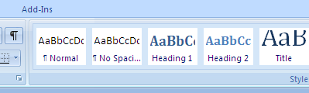

- For a subtitle, write one e.g. “Pre Arsene Wenger” or “Task 1”
- Highlight your sub title
- In word, in the “Home” menu, Click the “Heading 2” button
- Repeat for further titles/subtitles etc

How to use word to create contents page
Note: the following steps will place a table of contents wherever your flashing curser/prompt is
- Use the steps above to create your titles/sub titles, if you do not use the steps above your contents page will not work
- Click on the references menu at the top
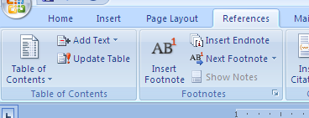
- Then click on “Table contents”
- Choose and click on an “Automatic Table”

Example:
Contents
How to use Word formatting to create titles and a contents page 1
How to use word to create contents page 1

